Level Design Document

<Level Name>

Table of Contents

# 

**Table of Contents 2**

**Change List 4**

**Level Overview 5**

Level Summary 5

Level Highlights 5

**Level Layout 6**

Complete Level Layout Image 6

Level Layout Information 6

Level Details 6

*Spawn Points 6*

*Narrative Information 6*

*Interactive Props 6*

*Memorable Props 7*

*Destruction Details 7*

**Key Location 1 8**

Location Summary 8

Location Map 8

Location Highlights 8

**Key Location 2 10**

Location Summary 10

Location Map 10

Location Highlights 10

**Key Location 3 12**

Location Summary 12

Location Map 12

Location Highlights 12

**Request Lists by Department 14**

Programming – Graphics 14

Programming – AI 14

Programming – Gameplay 14

Modelling/Characters 14

Modelling/Objects 14

Animation 14

Sound 14

SFX 14

**Reference Images 15**

# Change List

|  |  |  |
| --- | --- | --- |
| Date | Changed By | Change Description |
| <Change Date> | <Your Name> | <Change Description> |
|  |  |  |
|  |  |  |

# Level Overview

## Level Summary

Add level summary here

## Level Highlights

|  |  |
| --- | --- |
| **Location:** |  |
| **Type:** |  |
| **Time of Day:** |  |
| **Weather:** |  |
| **Unique Features:** |  |
| **Major Lighting Changes Needed:** |  |
| **Objective(s):** |  |

# Level Layout

## Complete Level Layout Image

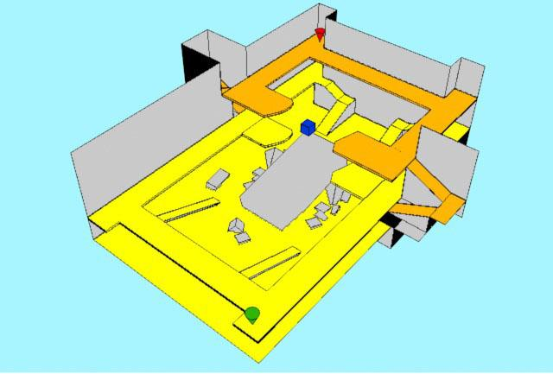

## Level Layout Information

add level layout info here

## Level Details

### Size

### Spawn Points

<Spawn Point Info>

### Narrative Information

<Narrative Information>

### Interactive Props

<Interactive Prop Info>

### Memorable Props

<Memorable Prop Info>

### Destruction Details

<Destruction Info>

# 

# Key Location 1

## Location Summary

add location summary here

## Location Map



## Location Highlights

|  |  |
| --- | --- |
| **Type:** |  |
| **Unique Features:** |  |
| **Weather:** |  |
| **Objectives:** |  |
| **Melee Support:** |  |
| **Mid-Range Support:** |  |
| **Long-Range Support:** |  |

# 

# Key Location 2

## Location Summary

add location summary here

## Location Map



## Location Highlights

|  |  |
| --- | --- |
| **Type:** |  |
| **Unique Features:** |  |
| **Weather:** |  |
| **Objectives:** |  |
| **Melee Support:** |  |
| **Mid-Range Support:** |  |
| **Long-Range Support:** |  |

# 

# Key Location 3

## Location Summary

add location summary here

## Location Map



## Location Highlights

## Location Highlights

|  |  |
| --- | --- |
| **Type:** |  |
| **Unique Features:** |  |
| **Weather:** |  |
| **Objectives:** |  |
| **Melee Support:** |  |
| **Mid-Range Support:** |  |
| **Long-Range Support:** |  |

# Request Lists by Department

## Programming

1. Request 1
2. Request 2

## Modelling/Characters

1. Request 1
2. Request 2

## Modelling/Objects

1. Request 1
2. Request 2

## Animation

1. Request 1
2. Request 2

## Sound

1. Request 1
2. Request 2

## SFX

1. Request 1
2. Request 2

# Reference Images